ACIS 2023 Reviewer Guidelines
(Last updated Aug 27th, 2023)

Prepared by:
Wasana Bandara
Mary Tate
Farhaan Mirza

Contents
Introduction 3
Basic Review guidelines 3
Easy-Chair Instructions 5
Log in to the conference system. 5
Creating an EasyChair account 5
Accept the invitation to review the submissions. 7
Finding your way around Easy Chair 8
Complete the review of the assigned submission. 10

Introduction
Thank you for your commitment to the ACIS 2023 conference as a paper reviewer. Your valuable insights and expertise play a crucial role in ensuring the quality and impact of the conference's proceedings. This document provides you with comprehensive instructions to navigate the EasyChair platform for reviewing papers.
The reviewers are expected to provide constructive feedback on the submitted work (as per review guidelines below).

Please ensure that you carefully follow these guidelines to maintain a smooth and efficient review process. Your contribution is pivotal to the success of ACIS 2023, and we appreciate your dedication to the scholarly community.

Basic Review guidelines
Reviewers need to be aware of the essential steps and criteria related to assessing submissions for ACIS 2023. They should also carefully read the Track Descriptions for the track for which they are reviewing as well as the Types of Submissions information that specifies criteria for the different kinds of submissions (e.g., Completed Research paper, Short paper, Poster slam etc.). Please become familiar with the Reviewer component of the Easy Chair System as configured for ACIS 2023, as described in this guide.

Please note that all reviews are due by Sept 25th, 2023.
Overall Goal: Reviewers should review papers with the intention that no paper with merit be excluded from the conference.

Timely reviewing: Please submit your reviews on time. We are running to a very tight deadline. All reviews are due by Sept 25th. To facilitate the review process, please promptly reply to the reviewing invitation.
Conflict of interest: You should not review papers with which you have a conflict of interest (CoI). If you encounter a conflict of interest, please declare this ASAP to your Track Chair
Review accountability: Please inform the TCs if a colleague wrote the review on your behalf, and name that colleague so that we can publish their name as an acknowledgement. Regardless of who wrote the review, you have the ultimate responsibility for it; this means that you should check it before submitting it and correct any errors or deficits.

Developmental Reviewing: Reviews should be developmental. Try to offer some suggestions for improvement, even for weak/probably rejected papers.

Don’t “hard code” decision recommendations: Please DO NOT make comments recommending a reject or decline decisions in the review intended for the authors. This is very important as until a picture of overall acceptance rates is developed it will likely not be clear where borderline papers fall.
You can use the special field “Confidential remarks to the program committee” to share comments specifically with the Track/Program Chairs – which will not be shared with the Authors.

Review content & length: As good practice, each review should start with a short statement that summarises the paper. The statement then should follow with a summary of positive aspects of the paper. The reviewers should explain the weaknesses of the paper (i.e., what the weaknesses are and WHY they are weaknesses) and should make clear and constructive recommendations for improvement. Thus, while we have no specific minimum word limit for reviews, it is unreasonable to expect that a one-paragraph review would sufficiently cover the above aspects expected in a review. As a rough guideline, reviews should be at least 500 words long

Prizes and Awards: In your comments to the track chair you can indicate if you feel a paper should be considered for an award. You can check out the awards that are available. https://acis.aaisnet.org/acis2023/submission/awards/

AI or ChatGPT: If you have concerns but cannot verify that the paper or parts of it has been written with the use of AI (e.g., Chat GBT) and/or has plagiarized content, then please flag this to the track chair.
See below further details on how to navigate the ACIS 2023 paper submission system (Easy Chair) in your role as a reviewer.

Easy-Chair Instructions

Log in to the conference system.
To access the paper review process for ACIS 2023, follow these steps:
a) Visit the EasyChair ACIS 2023 Conference Webpage:
You should have already received the invitation email for the PC, together with a link to connect to the login page. The link ACIS2023 is https://easychair.org/conferences/?conf=acis2023
As well, there will be a link to follow in the email. If you are not already signed into Easy Chair you will have to sign in using your login information.
b) Logging in with Existing EasyChair Account: Once you have an EasyChair account, proceed with the following:
Enter your registered Username and Password in the provided fields.
Click the "Log In" button to access your account.
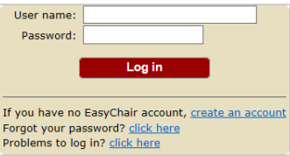

Creating an EasyChair account
The following steps explain how to change your role on EasyChair:
For First-Time Users on EasyChair: If you are using EasyChair for the first time, follow the instructions as detailed below to set up your account.
Click on “Create an account”. Follow the on-screen procedure.
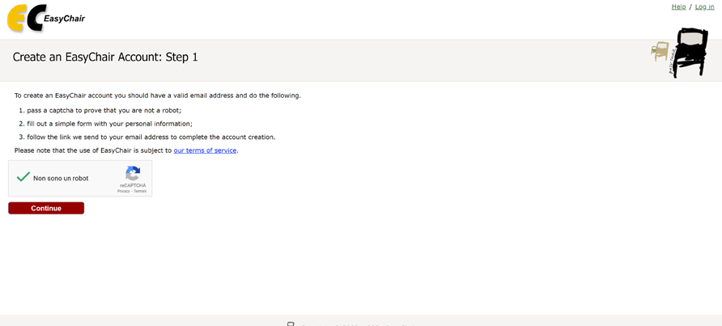
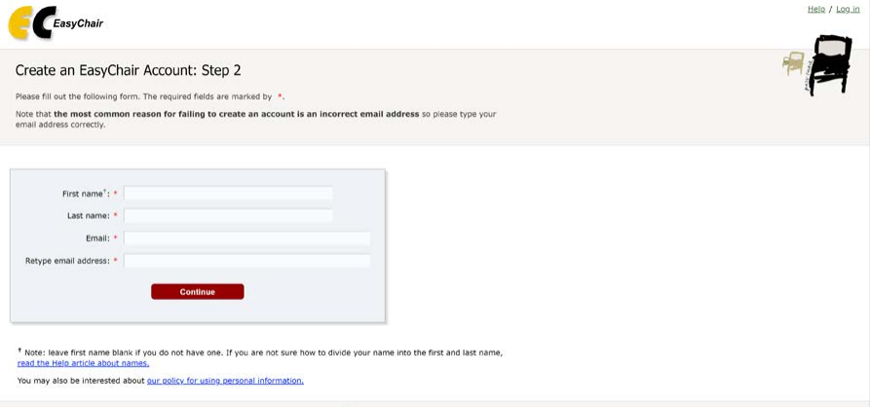
Fill out the displayed form.
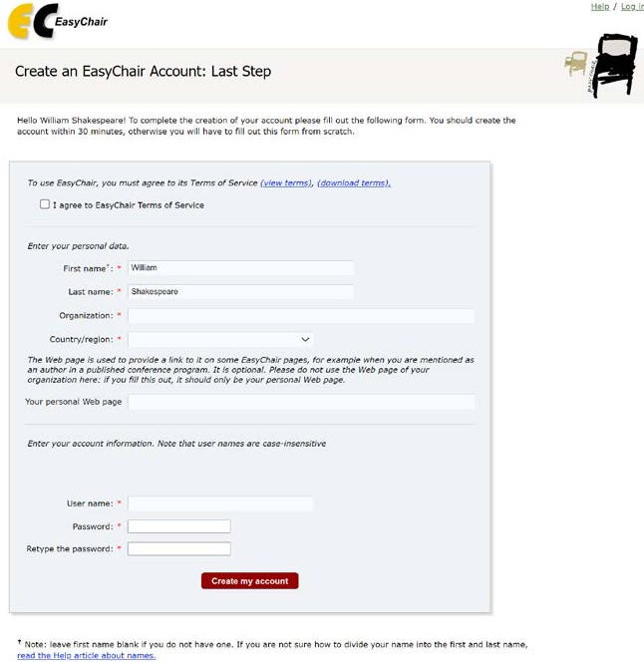

After registering, you will receive an email to confirm your email address. Click on the link provided in the email to continue the account registration process.

Accept the invitation to review the submissions.
When you are invited to review a paper for ACIS, you will get an email notification from Easy Chair, asking you to accept the review.
Once you access the information on the review assignment, you can now respond to the review request by clicking the ‘Answer request’ in the right menu. You need to accept the review request in order to write the review. You can also decline the review request here. Please answer the request as soon as possible to let the person who requested your assistance with the review know whether you are willing to review the paper or not. This is very important to make sure that all papers get the reviewers willing to complete the review on time.
You can also add a message to the person who requested the review from you, suggesting other possible reviewers or adding any information you deem necessary. This message (along with your decision) will be sent to the person who requested the review from you when you click the Select and/or send message button. See example below
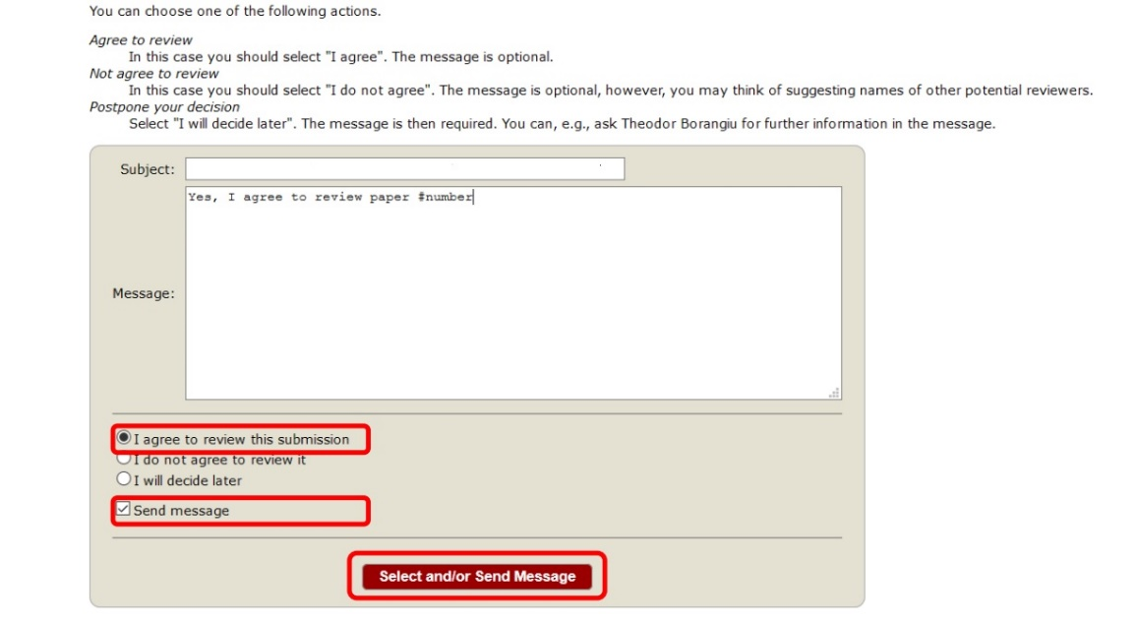

Finding your way around Easy Chair

If You Are Already an Author for ACIS2023: If you have previously been associated with ACIS2023 as an "author" and now need to change your role to review a paper, follow these steps:

Log In: Access your EasyChair account by visiting the conference webpage: https://easychair.org/conferences/?conf=acis2023
Navigate to Conference Tab: Once logged in, you will find a navigation menu. Locate the "Conference" tab and click on it.

Change Role: Under the "Conference" tab, find and select the option labeled "Change Role."
In the "Change Role" section, you will see a list of available roles.

You can also select the role you want to navigate the system as you enter into Easy Chair. It will list the current roles you hold for ACIS 2023, as illustrated below.

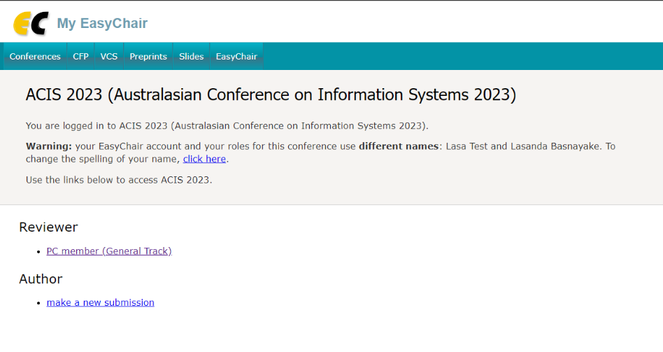

Once you have selected the role as a reviewer, you can access the papers assigned to you by going into the “Review” “Assigned to me” tabs.

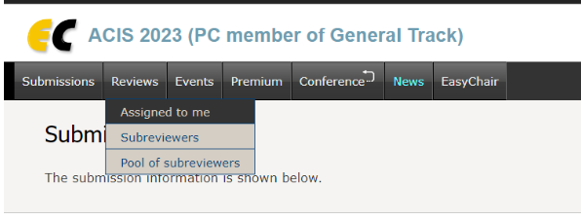

You can see all the papers assigned to you in a list. Here you can download the paper(s) (see the Folder symbol), see the details of the paper (see the “i” symbol), add a review (see the ‘+’ sign saying “Add a new Review” etc.).

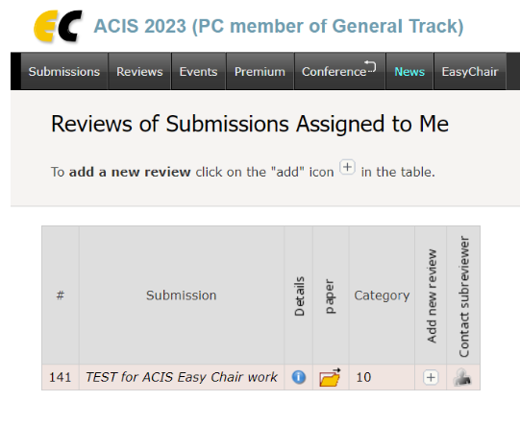

Complete the review of the assigned submission.
When you are ready to complete the review, you will also need to access the submission again via EasyChair (as above)
When you are ready, complete the review form. You will be required to rate the submission against the six criteria for selection using a five-point scale (5: Excellent – 1: Very Poor).
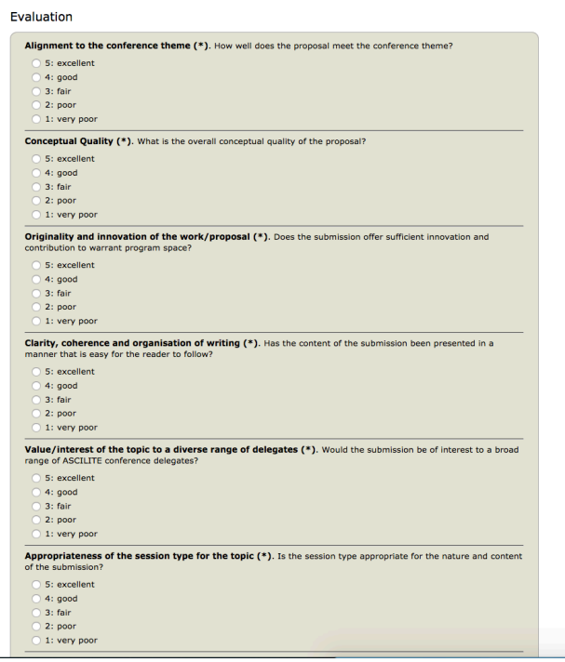

Provide an overall evaluation of the submission. Make sure you include text comments for the author/s to make revisions. You may wish to number your comments to assist the author in responding to your feedback. Remember, anything you write in this field will be visible to the authors when reviews are returned.
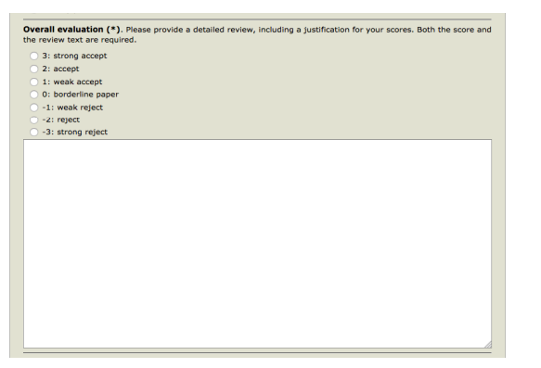
If you would like to make some confidential comments to the Organizing Committee, please use the space provided.
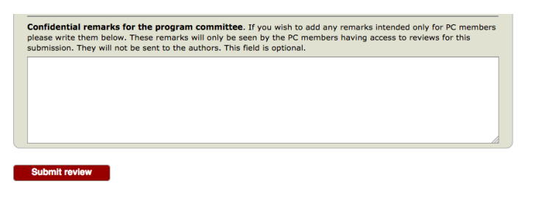
After you click on submit review, you will receive a confirmation message with a summary of your review.
*Please make sure that your review notes adhere to the basic review guidelines described above. Provide constructive, developmental feedback please.

